Scope
Some breaks of the power supply in the PT5664/50 have shown to be caused by a high tension capacitor, not living up the usual quality.
Therefore we have introduced a change of capacitor type which cures the main problem: flash-over in the capacitor. A flash over may cause the power supply to malfunction. At the same time two other changes which makes the operation more reliable.

Modification
Capacitor C-063 (10nF) to be changed to 2 pcs. 4,7nF, make: MuRata: DE1610-452E472M-KXSMKX12C50
Part number: 4008 102 05000

Both capacitors to be mounted as shown below:

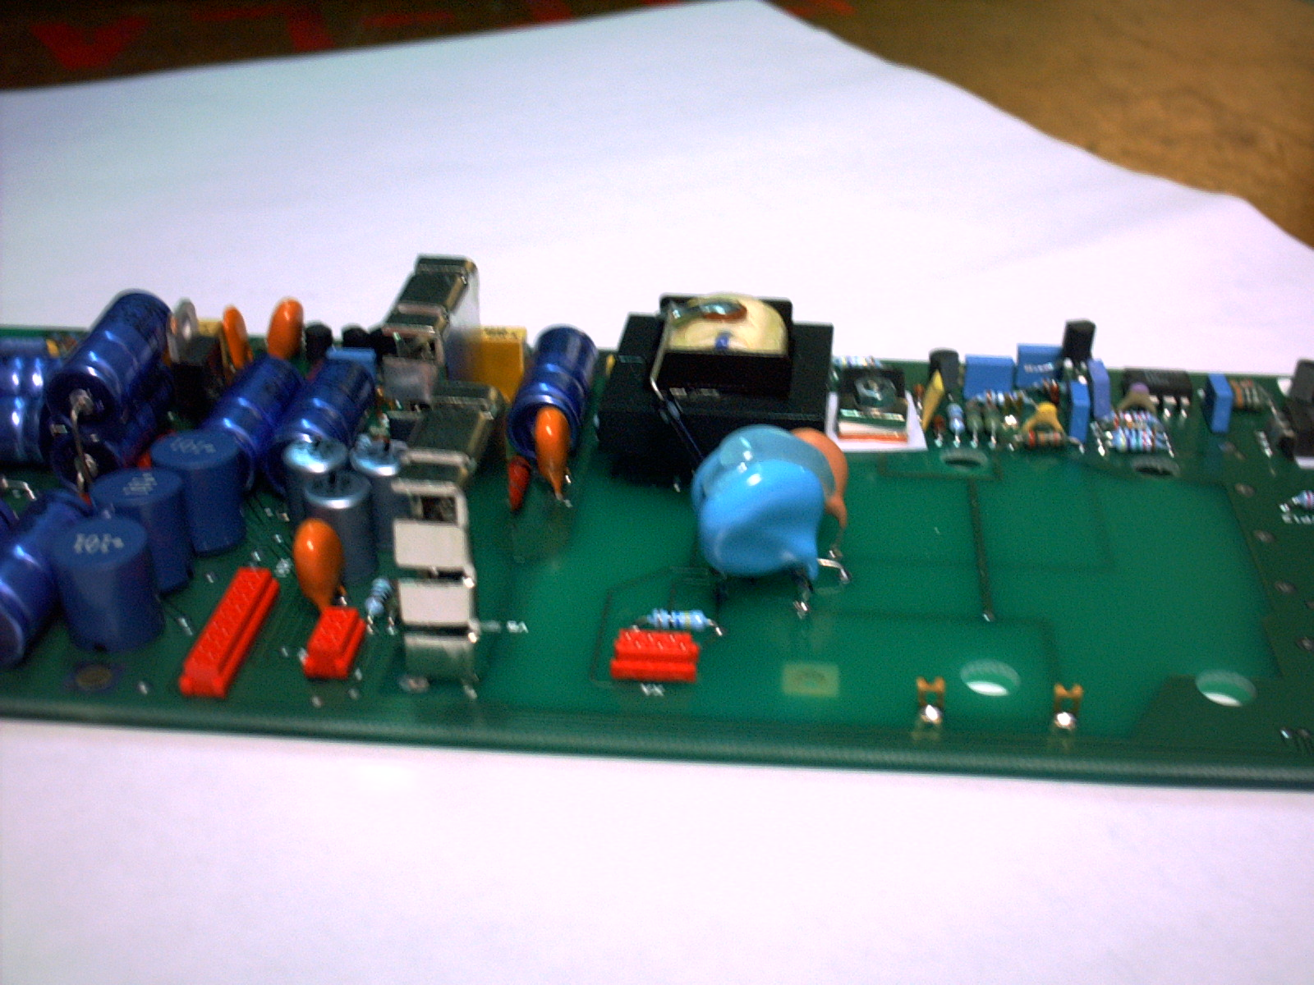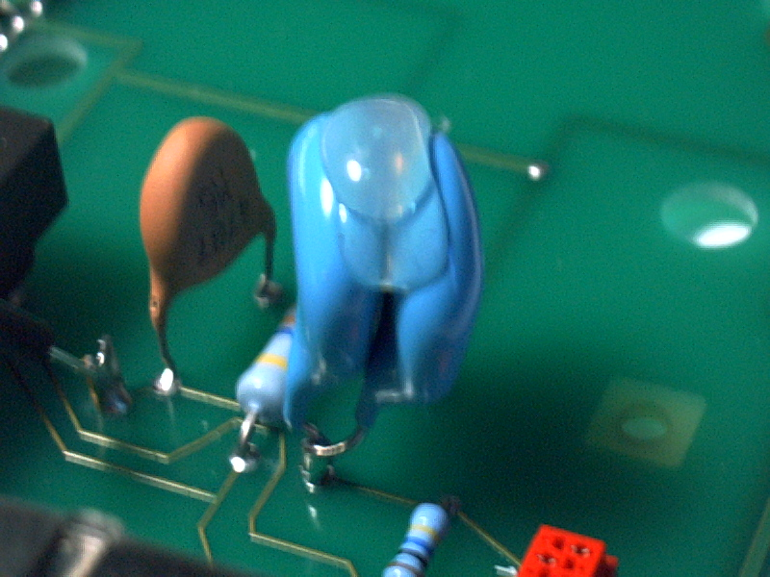

A diode BAW 61 to be mounted on the emitter of Q-7; the cathodes of the diode is directed towards the PCB as indicated on the photo below:
Part number: 9331 012 20113

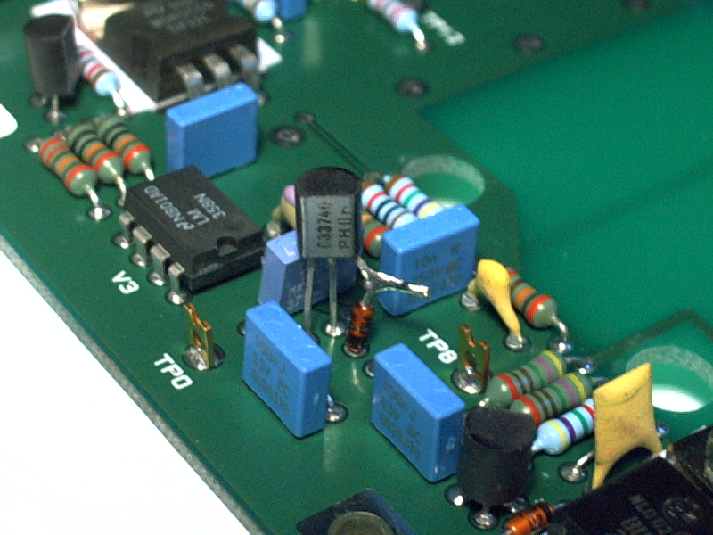

A diode BYV-27 is mounted on the solder side of the PCB. Please refer to picture below:
Part number: 9335 435 10112

